Stonehenge, Salisbury, Old Sarum
& Wiltshire Landscapes

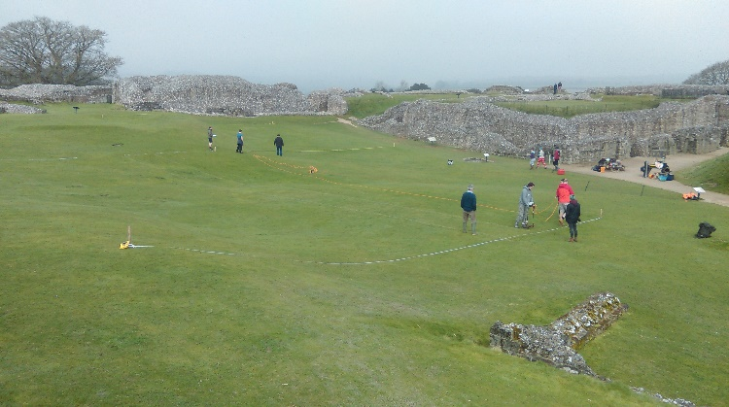
Saturday 21 January 2017
10.00 - 16:00
Avenue Campus
Building 65
Lecture Theatre C

10:00 | Registration & Coffee
10:10 | Welcome
10:15 | Talk 1: The Beginnings of Monumentality in the Stonehenge and Avebury WHS  Dr Josh Pollard and Dr David Wheatley, Department of Archaeology, University of Southampton  Why were the Stonehenge and Avebury landscapes the focus for major monument building during the Neolithic (c.4000-2400 BC). The apogee comes in the mid 3rd millennium BC with the building of the main sarsen and bluestone phase at Stonehenge, the Avebury henge, Durrington Walls, Silbury Hill, etc., but what of the beginnings, and how did events during the earlier part of the Neolithic structure what was to come later? The last two decades have seen a considerable amount of archaeological research, involving both fieldwork and new analyses. This will form the basis for a review of the region’s earliest monuments and their legacy.
11:00 | Talk 2: The Age of Great Monuments: Stonehenge, Avebury and Times of Change  Dr David Wheatley and Dr Josh Pollard, Department of Archaeology, University of Southampton  This second lecture builds upon the first, taking the story of the rising extra-regional significance of the region into the 3rd millennium BC and the creation of some of the most iconic Neolithic monuments in Europe. It reviews current understanding of Stonehenge and Avebury and looks at outstanding issues and planned fieldwork. Thoughts are offer on the dynamic relationship between the two landscapes during the later Neolithic (competition, emulation, networks, etc.), and one why the centuries around 2500 BC were a time of such colossal undertaking.
11:30 | Coffee
11:45 | Talk 3: Old Sarum, Searobyrg and late-Saxon Urbanism  Dr Alex Langlands, Department of History, University of Swansea  In the thirteenth-century historical sources Old Sarum emerges as an important central place; a diocesian capital with castle, borough and assembly place to match. This study session will look at the emergence of this distinclty ‘urban’ place and will consider the evidence for Old Sarum’s importance in the post-Roman, the Anglo-Saxon and early Norman period, arguing that these later civil and administrative functions have their origins in the pre-Conquest period. This is a study that involves the interdisciplinary analysis of a range of evidence: hard archaeology, cartography, historical sources materials, place-names and folklore.
12:30 | Lunch
13:30 | Talk 4: Old Sarum and its Environs. New Field Research in an Ancient Landscape  Mr Kristian Strutt, Department of Archaeology, University of Southampton  As part of the recently established Old Sarum Landscapes Project, a programme of archive research and fieldwork is being conducted by the University of Southampton and the University of Swansea. The latter component of the project has comprised three seasons of archaeological survey in and around the ancient monument of Old Sarum, complementing the ongoing documentary and archive research. This paper will present the latest results of the fieldwork, explaining the methodology that has been applied to date, and looking at some of the findings of the 2014-16 field seasons, including the incredible results of geophysical survey in the outer bailey of Old Sarum, and the results of survey in the fields to the South and east of the monument, pointing to a long period of settlement in the Roman and medieval periods.
14:30  14:45  15:45 | Coffee  Talk 5: Old Sarum cathedral and the move to New Salisbury  Dr Nick Karn, Department of History, University of Southampton  Between the later eleventh century and the early thirteenth, the cathedral at Old Sarum exercised wide influence across Wiltshire and beyond. It was founded as a replacement for older but problematic sees at Sherborne and Ramsbury; because this was so much later than many other English sees, the process of creating the cathedral can be understood from the richer documentation of the later period. Therefore, this talk will explain how the cathedral developed, how it worked and how it related to the region. This will involve discussion of how the building developed and was used, consideration of how the chapter and organisation of the cathedral developed, and coverage of how the cathedral related to city, castle and county. For over a century, the cathedral at Old Sarum prospered, but it came to be seen as problematic in the early thirteenth century, which led to the move down into the Avon valley; this talk will also consider the difficulties that prompted the move itself.  Questions and Discussions
16:00 End of Day

